UNIVERSITY OF DAR-ES SALAAM

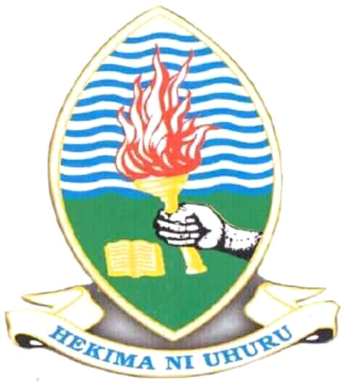

COLLEGE OF INFORMATION AND COMMUNICATION TECHNOLOGIES

(CoICT)

DEPARTMENT OF COMPUTER SCIENCE AND ENGINEERING

IS 282 PROJECT REPORT

PROJECT TITLE: ELECTRONICS MEDICAL RECORD SYSTEM (EMR System)

Student Name Omary, Chichi Saidy

Reg No 2017-04-01601

Years of Study II

Supervisor’s Name Dr. J. Lungo

**ABSTRACT**

EMR Is the web application which collect the patients and population electronically stored health information in a digital format. This application or system help to prevent the loss of patient information by compiling it in one database, also it helps to lower the amount of a paper being used in a clinical setting. And this record can be shared across different health care setting, example from one hospital to another both in urban and rural areas through finger print of patients where the Doctors may be able to see all information of the patients from his or her previous hospitals used to get services. After that Doctor can be able to add on or to cure the patients according his or her problem concern also Doctor will be able to send the patient to the laboratory for more checkup.